10-2-23 Notes
Introduction to Pandas and Jupyter
Goals:
By the end of this lesson, you will be able to:
- Serve Jupyter Notebook files from local directories and connect to your development environment.
- Create Pandas DataFrames.
- Run functions on Pandas DataFrames.
- Read and write DataFrames to and from CSV files with Pandas.

Python dictionaries don’t use .append if you want to add a record.
- Dictionaries use .update as the command.
Dictionaries use Key+Value for each record, Whereas a list is just a bunch of lines of data.
- To put it another way, a dictionary allows you to add a new column of data type, and a list is just one column.
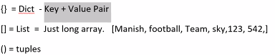
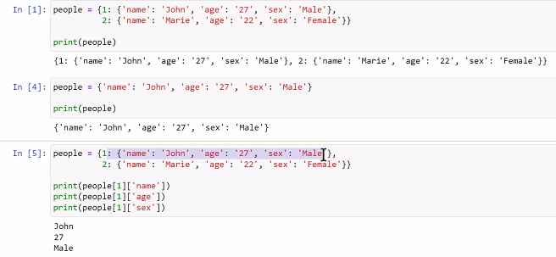

In Anaconda, NEVER work in Base environment. If you mess it up, it’s REALLY bad.
- Always use Dev environment
- 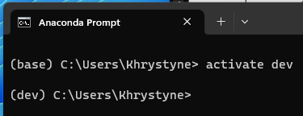
Jupyter notebook makes a localhost temporary server that’s just your computer. It opens in the default browser
If you use Cell in the menu bar, you can clear all outputs
If you Save in Jupyter Notebook, it saves on your computer
Dot in upper right next to Kernal designates the code is running still. If it’s a circle, it’s not running.
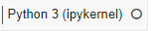
MAKE SURE YOU SET YOUR ENVIRONMENT AND INSTALL CORRECT LIBRARIES AT THE BEGINNING

Comix Remix Solution
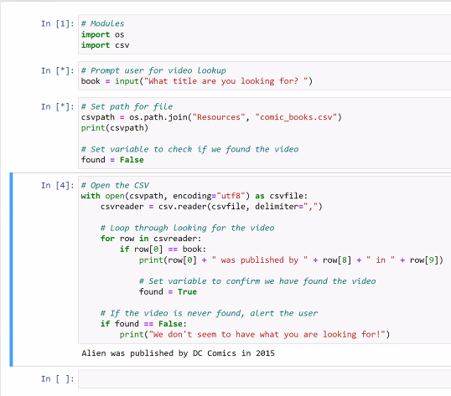

Pandas
Each column in a DataFrame is a Series
Pandas makes a dataframe out of data. In the In [3] below, it’s using a dictionary that we typed in. Most of the time when we use it, it’ll be using a .csv file, Excel, or .txt file
Pandas cares about capitalization for the commands. Whether you capitalize variables or not is personal.
- Examples: data_series = pd.Series, painting_df = pd.DataFrame

Creating Data Frames Solution:
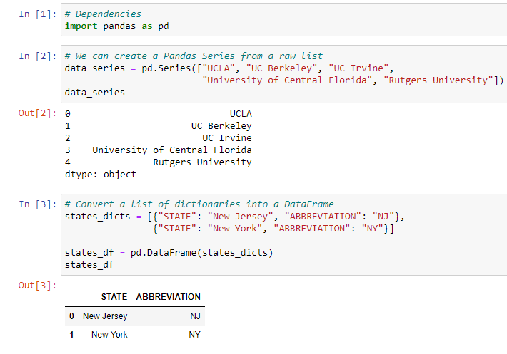
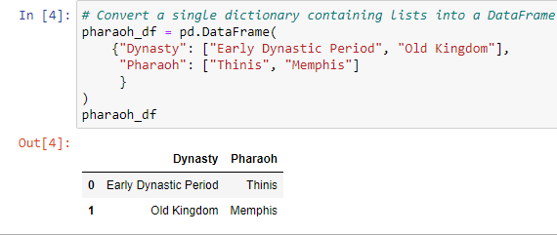

7:08pm- installing and using Jupyter notebook previewer in VS Code

DataFrame shop solution:
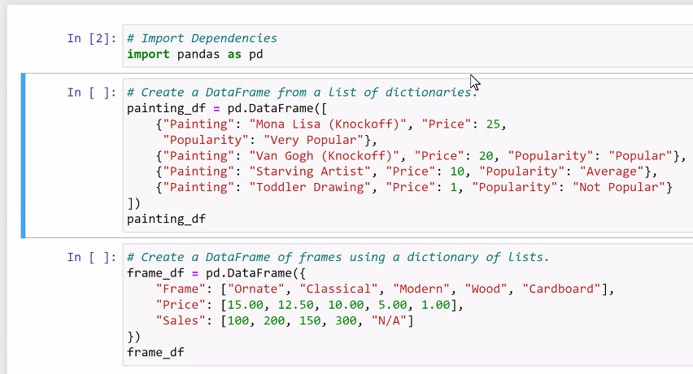
Outputs:
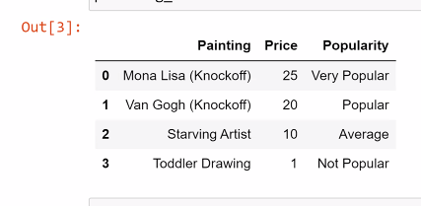
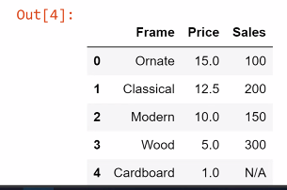

Pandas functions:
head() shows minified version of a much larger table. First 5 rows by default. You can put a number in the parentheses if you want a different number of rows.
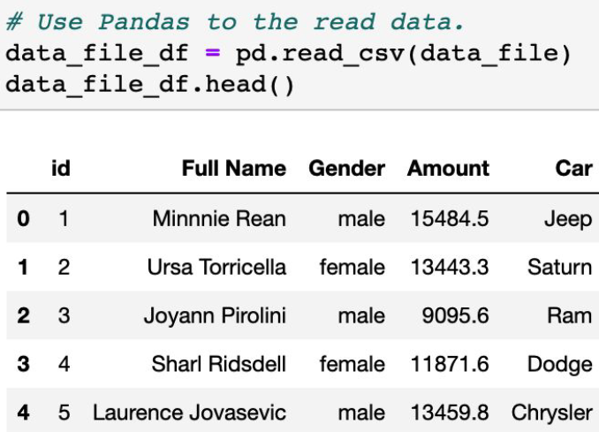

describe() prints out a DataFrame containing some analysis of the table and its columns.
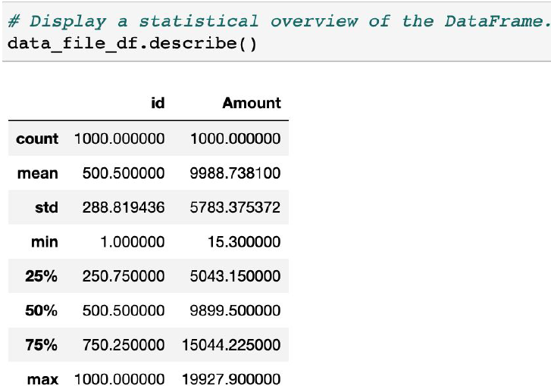

mean() computes the average of a set
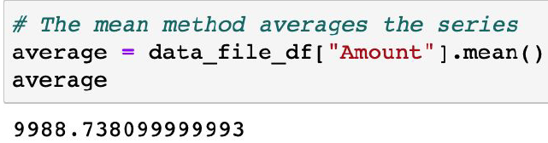

sum() adds the values
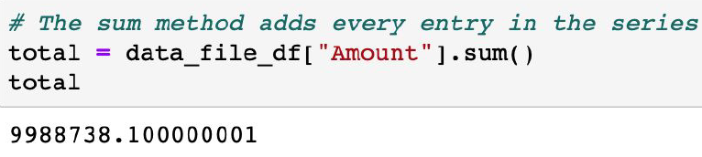

unique() returns each unique value in a series

value_counts returns a list of unique values, and a count of how many times each unique value appears

New columns based on a calculation:
Line 1- Create variable series of data based on calculation
Line 2- make a column, and assign it to hold the variable series in line 1
Line 4- Print the top 5 rows of the data set.

You can use Pandas functions on a series (single column)
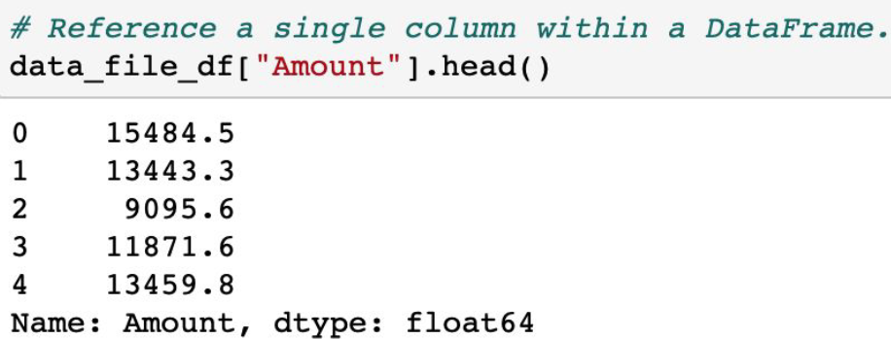

Or you can use functions on multiple series as well.
Double brackets in example below are because it’s a list of lists.
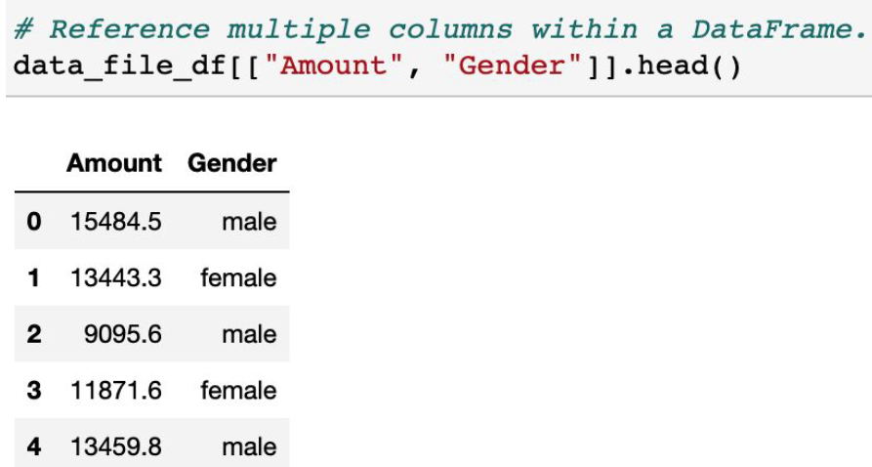
In Jupyter, if you type a period and hit tab, it’ll show a dropdown of options to type after the period.

Modifying Columns:

rename() renames a column
- What it is is on the left, new name on right

.columns prints an object that lists the column names. NO PARENTHESES.

Reorganizing column order

Reading/Writing csv files:

Reading:
Encoding is mostly not required, but you can add it if you get an error message.

Writing:

Comic Books pt 1 solution:
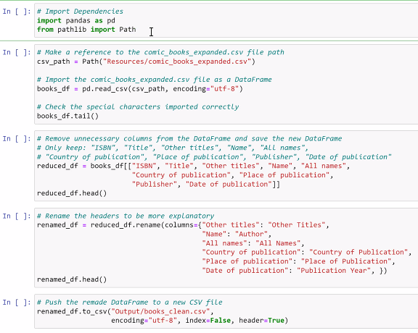

Comic Books pt 2 solution:
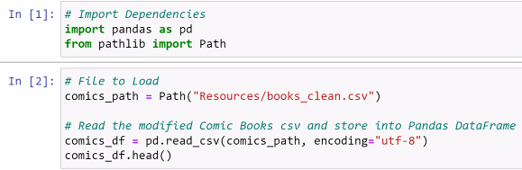
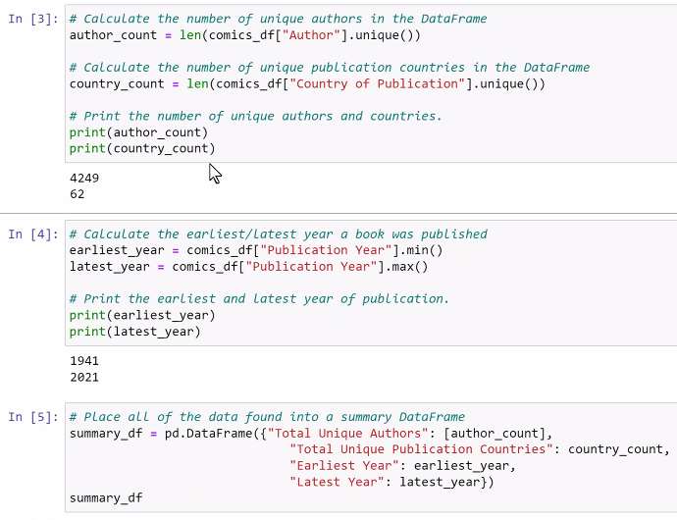
Last chunk (In [5]) makes a new data frame dictionary, making new keys and pulling values out of already ran code.
- Square brackets required around the value for the first key.
- This allows you to break out data into a different file (ie: count of authors by year).

Carson the Guru’s wisdom:
Pandas has 4 data types
- Object (same as string in python)
- Int 64
- Int float
- DateTime

If you do a .unique() on a column, treat it as a list
Question- Formatting wise? Use [] not ()?

